OBJECT DETECTION FOR BLIND AND DEAF PEOPLE IN A VIDEO SCENE

Harika D #1, Lebasini RR#2, Rupa Sree D#3, Dr. R. Josephine Leela#4

*#Computer Science and Engineering Department, Panimalar Engineering College  
Chennai, India*

1harikadharmarajula4@gmail.com

[2](mailto:2lebasini27@gmail.com )[lebasini27@gmail.com](mailto:2lebasini27@gmail.com )

[3](mailto:3keerthanadhanasingh@gmail.com)rupasree454@gmail.com

4pitleela2016@gmail.com

***Abstract*— Obstacle detection and warning can improve the camera as well as the safety of visually impaired and deaf people especially in unfamiliar environments. For this, firstly, obstacles are detected and localized and then the information of the obstacles will be sent to the visually impaired and deaf people by using different modalities such as voice, vibration.**

***Keywords***— ***Real time Object Detection; Facial Recognition; SSD; Raspberry Pi; Vibration; Visually Impaired.***

1. Introduction

This paper investigates methods and procedures to construct an efficient system to assist blinds in their everyday life. In particular, various technologies that can be utilized to build a wearable system are examined. The machine vision and the communication component of the blind navigation and guidance is designed not only to search the surroundings environment but also to determine a safe. This work highlights the importance and also provides the instructions to blinds for efficient navigation and safe guidance by incorporating object/pedestrian detection in real-time.

The algorithm of this paper is SSD (Single Shot Detector) which is efficient for real-time robust system development. Here the processing server is separate from the input device. There has to be a connection over the cellular device and the server-side database which has to be on online mode for maximum continuous facility.

1. LITERATURE SURVEY

Shubham Melvin Felix [1], In today’s advanced hi-tech world, the need of independent living is recognized in case of visually impaired people who are facing main problem of social restrictiveness. They suffer in strange surroundings without any manual aid. Visual information is the basis for most tasks, so visually impaired people are at disadvantage because necessary information about the surrounding environment is not available. With the recent advances in inclusive technology, it is possible to extend the support given to people with visual impairment. This project is proposed to help those people who are blind or visually impaired using Artificial Intelligence, Machine Learning, Image and Text Recognition.

Giancarlo Iannizzotto [2], Recent development in smart assistants and smart home automation are lately attracting the interest and curiosity of consumers and researchers. Speech enabled virtual assistant offer a wide variety of network oriented service and in some cases can connect to smart environments, thus enhancing them with new and effective user interfaces. However, such devices also reveal new needs and some weaknesses. In particular, they represent faceless and blind assistants, unable to show a face, and therefore an emotion and unable to’see’ the user.

Prince Bose [3], The blind and the visually impaired have little to know internet presence because of the absence of cheap solutions to get them online which can be both hardware and software. Existing technology used for enabling the blind or visually impaired to use the internet or any digital form of information is dependent on braille displays and keyboards which are expensive and scares. Another shortcoming of existing technology is that out of all the visually impaired population, less than 2% know how to interpret braille. Hence voice controlled system for blind and the visually impaired was designed, which transceivers information in the form of audio.

1. Proposed model

Our proposed visual substitution system is based on the identification of object around the blind and deaf person. We propose a system that recognize and locate 2D in the video. This system should find the invariant characteristic of objects, provide the recognition and reduce the complexity of detection. We propose a method based on object extraction and matching in video. A comparison between query frame and database objects is made to detect object in each frame. For each object detected an audio file containing the information about it is activate.

MODULE DESIGN SPECIFICATION:

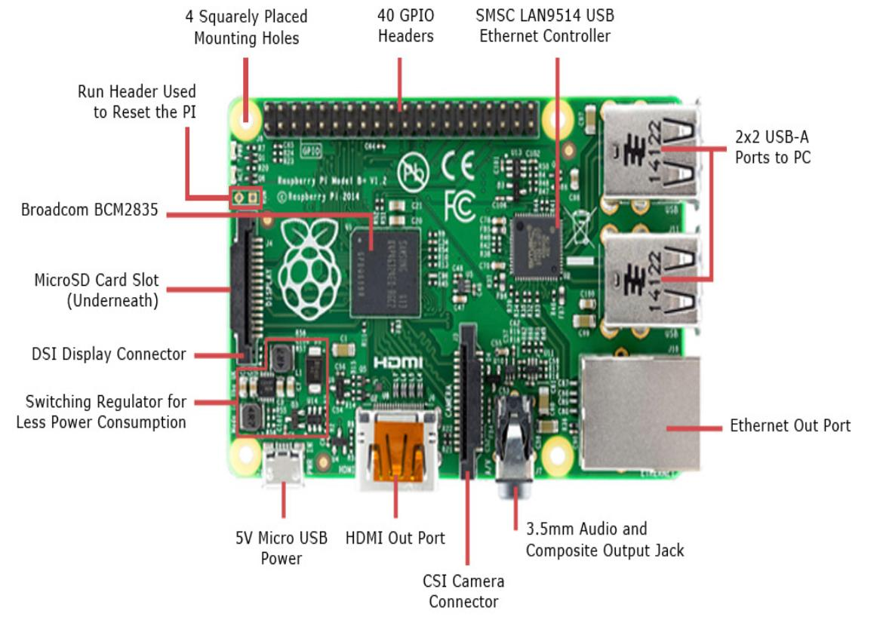

1. *Video Acquisition*

IP web cam application is installed in the android mobile. Once the server is installed and then copy the IP address and paste it in the code and then save it. Once the code is executed , then through the application the video is captured and the process takes place.

1. *Feature Extraction*

For extracting the feature, we are making use of MobileNet SSD algorithm. This features extraction is the process by which certain features of interest within an image are detected and represented for further processing.

1. *Object Detection*

Object is detected using single shot SSD algorithm which captures the object at a single shot. It is a single stage approach and it is more efficient than two stage approach.

1. *Training*

The objects of video captured is collected. The collected image is preprocessed and features like distance, object type are extracted. Based on the features extracted the model is trained.

1. *Testing*

The object from the camera is collected. The collected image is preprocessed and required features like distance, object type is extracted from the image. Based on the trained data, the system tests the feature extracted and predicts the object distance**.**

1. system architecture

Firstly, the USB camera captures the surrounding environment, from the input video features like

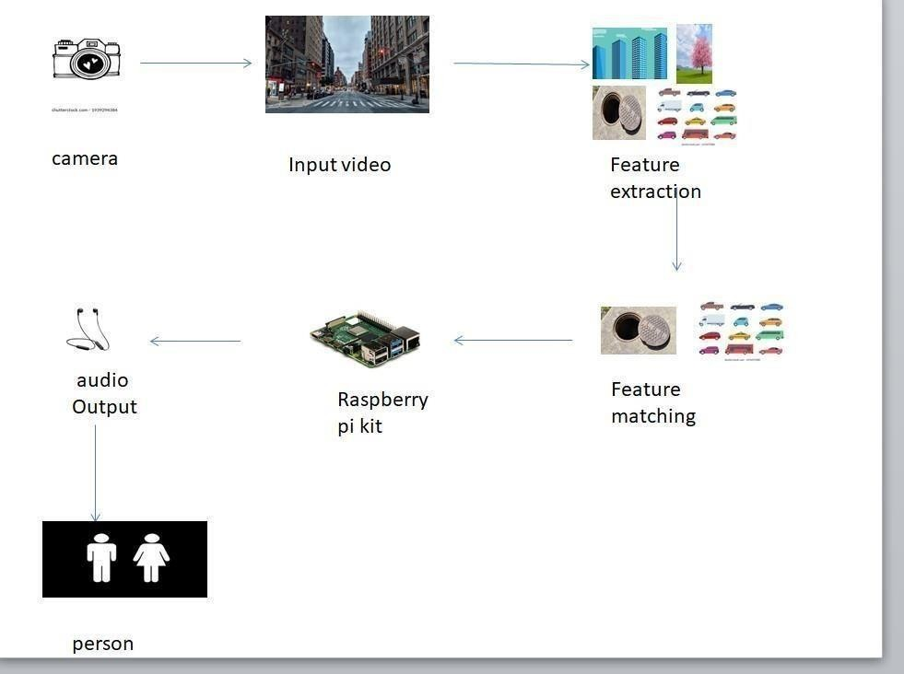

object type, distance accuracy are extracted. The extracted features are matched with already trained models. Once the feature is matched further process takes place in raspberry kit and it produces output in form of audio and vibrations.

1. results and discussion

This project provides a means of active interaction and navigation between the system and the blind person. Its features like interaction or commands over voice and reliable obstacle detections make its future scope huge. With the advancement in technology and our dependency on it, this project would be proved to be high in demand in the recent future. The test results prove that this system is more reliable than any other existing system, however, some more improvements can make it even more faithful and accurate. Also, the cost of this project is optimum and proves to be the best aid for blind people, and it will help them to be independent of their instincts and other people.

1. Conclusions and future enhancement

We present a visual substitution system for blind people based on object recognition in video scene. This system uses SIFTS key points extraction and features matching for object identification. We devote the experimental part to test the application in order to detect some objects in some video scene with different conditions. In this stage of works, we address the recognition of each object in the scene as an individual task, we do not consider the relationships between many objects. Thus, in future works, we will consider this relationship for scene understanding or detecting everything that belongs to a given place or location. Finally, in order to help bind people and to provide from the new technologies, a mobile application can be the best solution.

Acknowledgment

We would like to express my special thanks of gratitude to our HOD of Computer science department Dr. S.MURUGAVALLI and our guide Dr.R.JOSEPHINE LEELA as well as our principal who gave us the golden opportunity to do this wonderful project on the topic OBJECT DETECTION AND IDENTIFICATION FOR BLIND AND DEAF PEOPLE IN A VIDEO SCENE, which also helped us in doing a lot of Research and we came to know about so many new things. We are really thankful to them.

References

1. Shubham Melvin Felix, Sumer Kumar, and A. Veeramuthu, A Smart Personal AI Assistant for Visually Impaired People,2018.
2. Giancarlo Iannizzotto,Lucia Lo BelloAndrea,Nucita,Giorgio Mario Grasso, A vision and speech enabled, customizable, virtual assistant for smart environments,2018.
3. Prince Bose, Apurva Malpthak, Utkarsh Bansal, Ashish Harsola, Digital Assistant For The Blind,2017.
4. Md. Siddiqur Rahman Tanveer, M.M.A. Hashem and Md. Kowsar Hossain, Android Assistant EyeMate for Blind and Blind Tracker ,2015.

[5] Kumar Yelamarthi, Navigation Assistive System for the Blind using a

Portable Depth Sensor,2015.

[6] D. and J. H. Martin, “Logistic Regression,” in Speech and Language

Processing, 2015

[7] J. Huang, V. Rathod, C. Sun, M. Zhu, A. Korattikara, A. Fathi, I. Fischer,

Z. Wojna, Y. Song, S. Guadarrama, and K. Murphy, “Speed/Accuracy

Trade-Offs for Modern Convolutional Object Detectors,” 2017 IEEE

Conference on Computer Vision and Pattern Recognition (CVPR), 2017. [8] P.Y.Kumbhar,M.Attaullah,S.Dhere,andS.Hipparagi,“RealTime Face

Detection and Tracking Using OpenCV,” International Journal for

Research in Emerging Science And Technology, vol. 4, no. 4, pp. 39–

43, Apr. 2014.